Dataset: DataNation

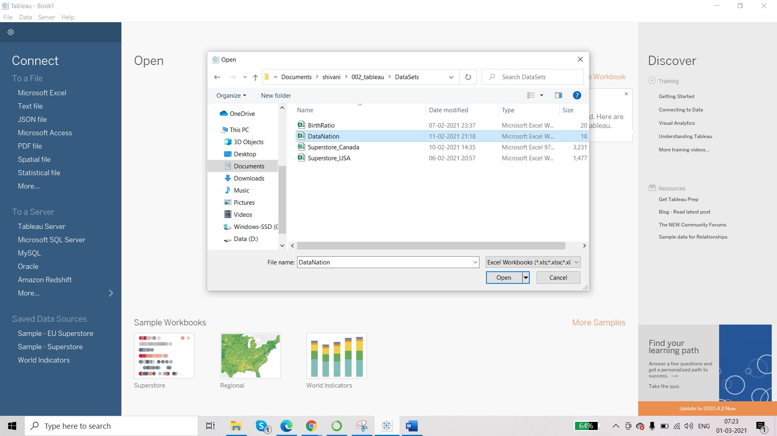

We have already created string and number calculations.

CityName

There are two ways to transform this dimension:

1. Point and click option- right click on dimension and select transform and then Custom Split.

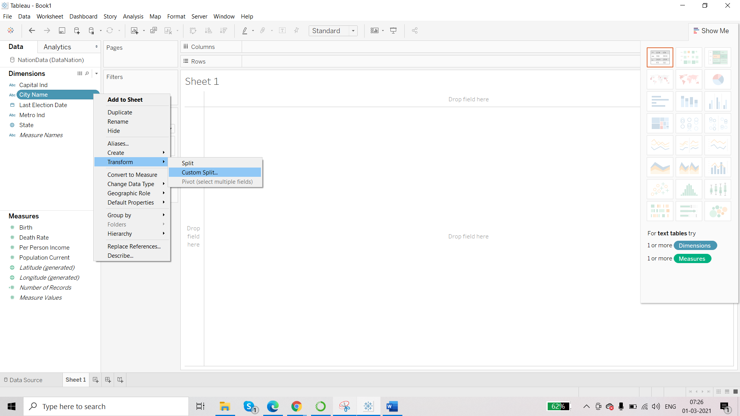

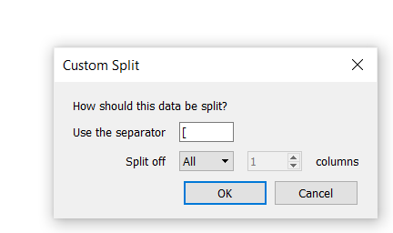

This will give result to 2 new dimensions.

1. You can use calculated field.

Whenever a dimension or a measure is either created as a result of calculated field or as a result of available options such as point and click options, you will have the datatype of the new dimension/measure which will start with the ‘=’ sign followed by icon of the datatype.

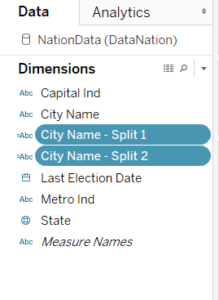

Check the City Name Split 1 by dragging into rows shelves. It appears correct. Rename this dimension as ‘City’

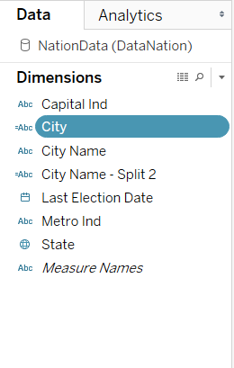

**Combining two Dimensions**

Select the dimension that you want to combine 🡪 right click on any one of them 🡪 Create 🡪 Combined Field

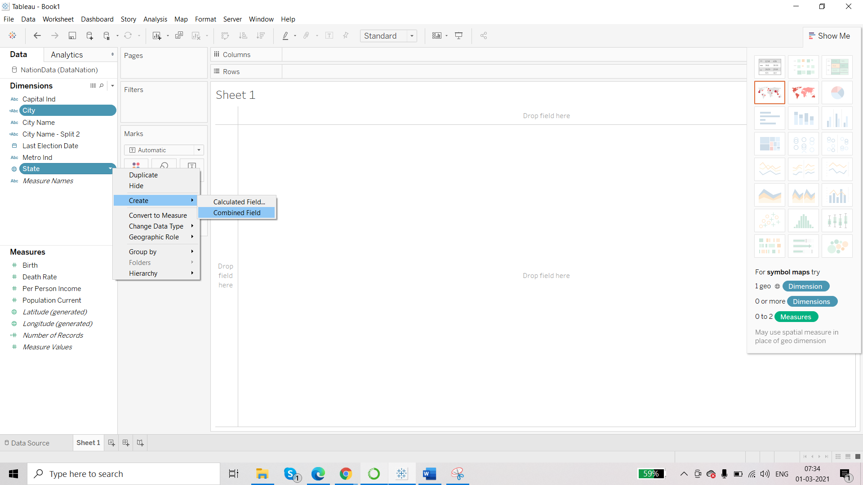

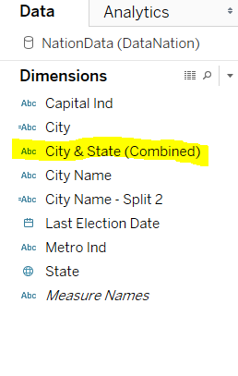

You can edit this combined field and rename this as Region. You can drag the fields to change the order and can change the separator too.

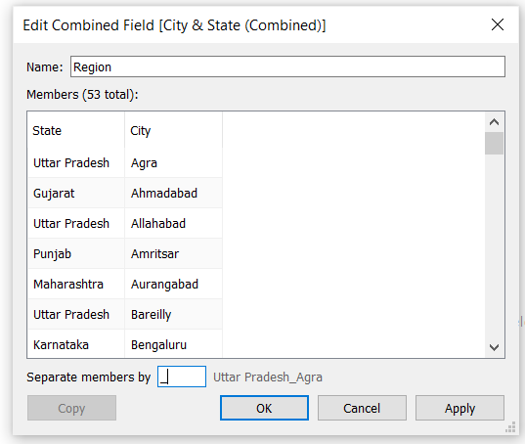

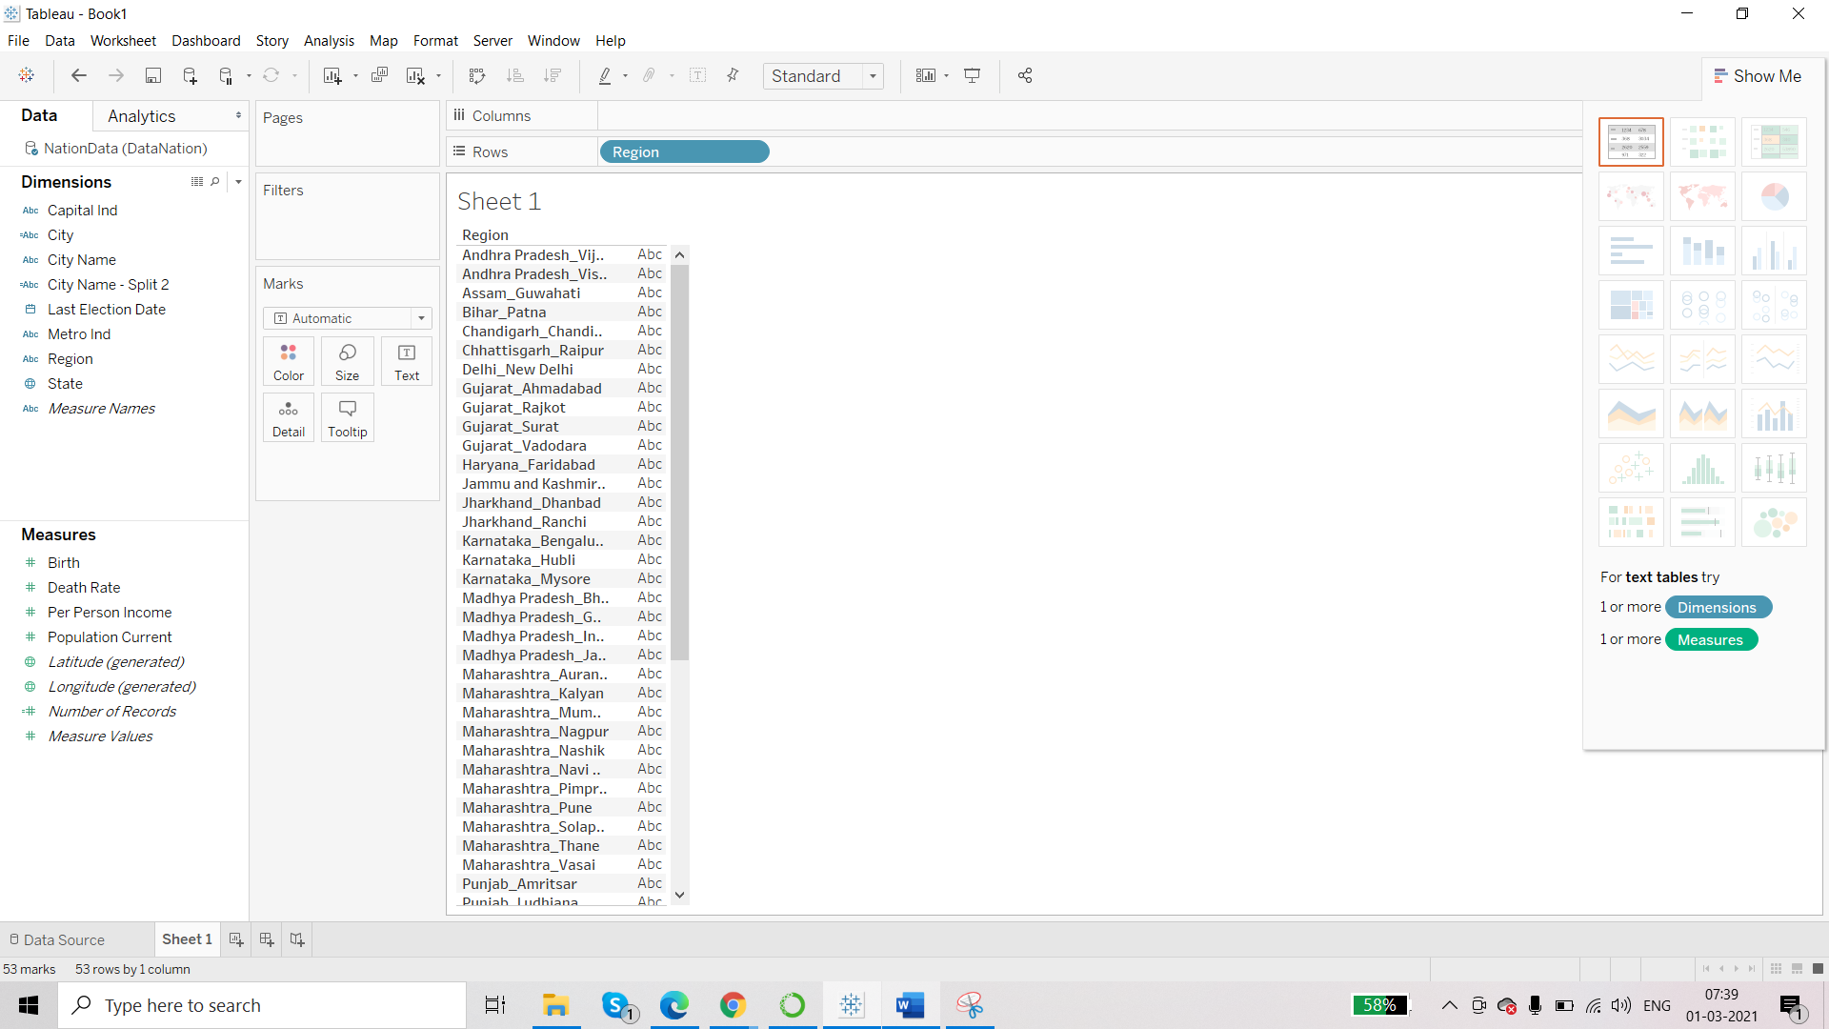

**Performing Date calculations in terms of calculated field**

Scenario – We want to find the number of years since the last election was held for each state or for each city.

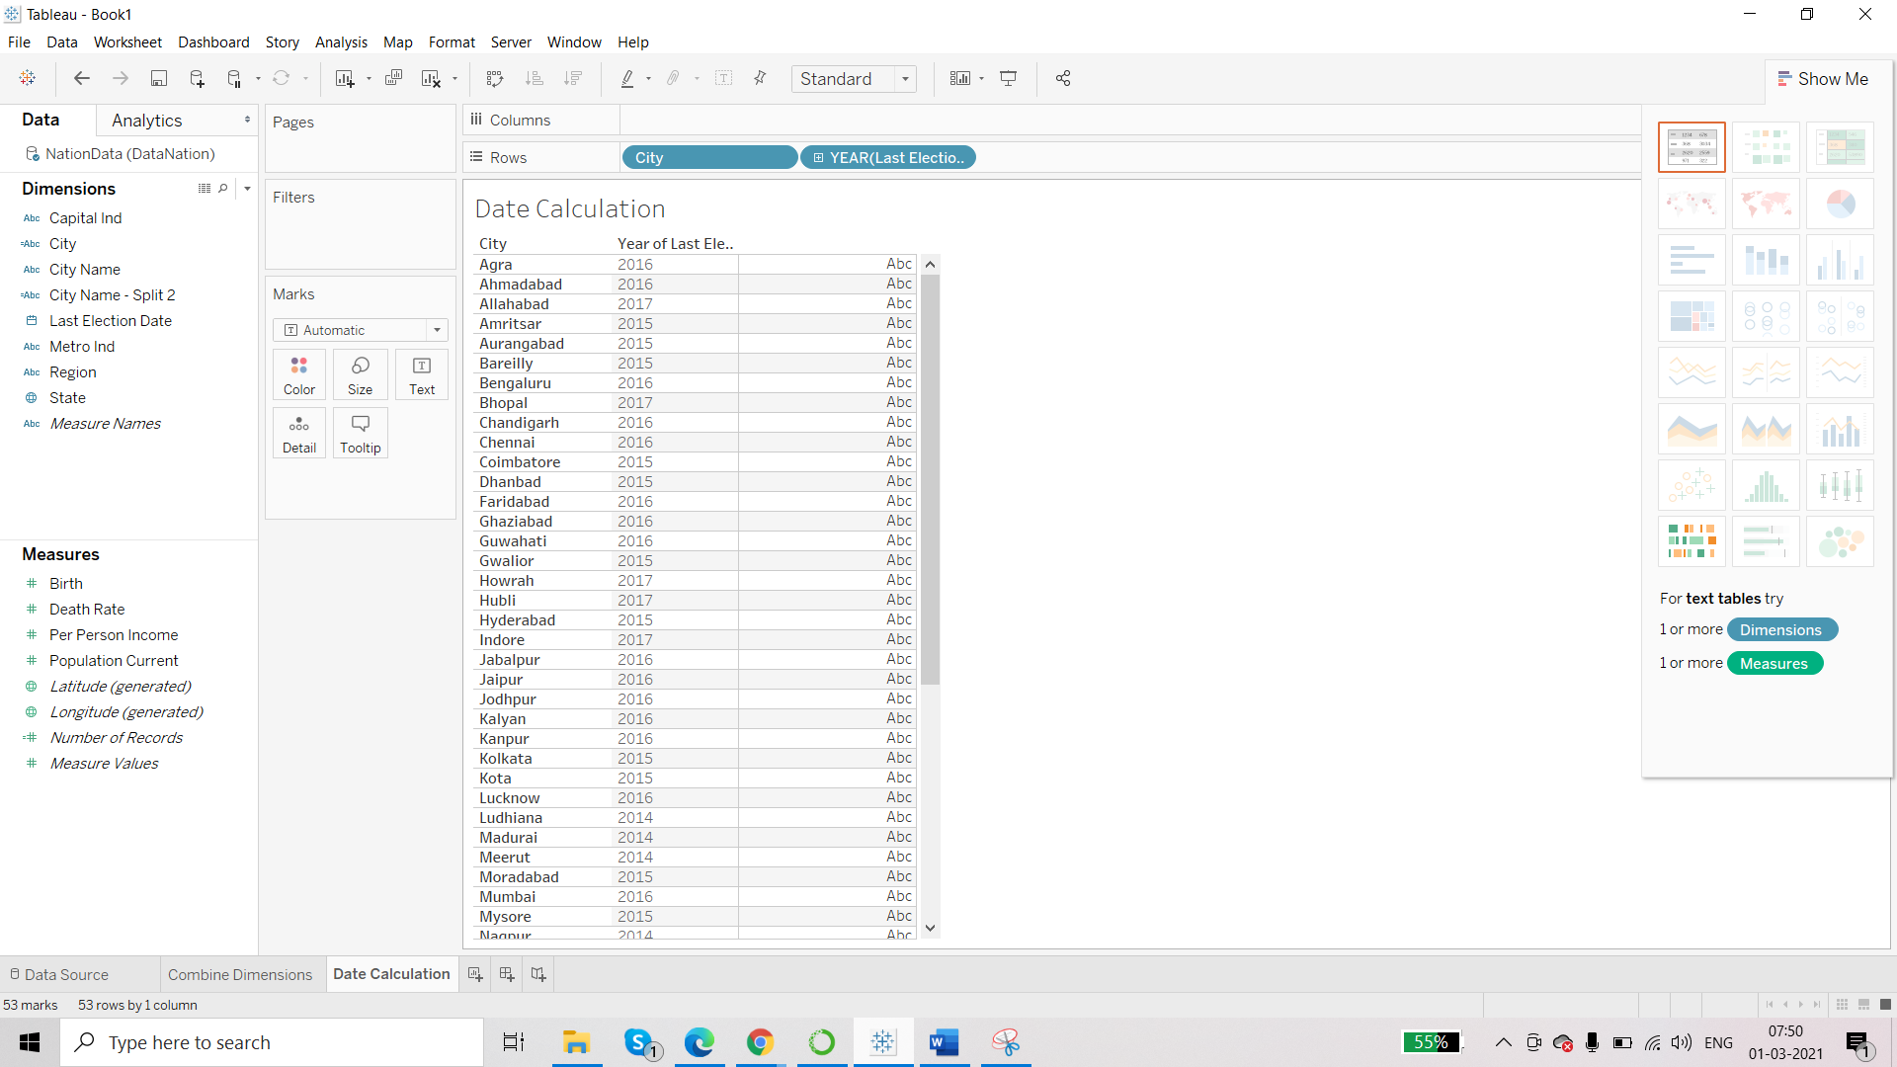

Now click on Create Calculated Field.

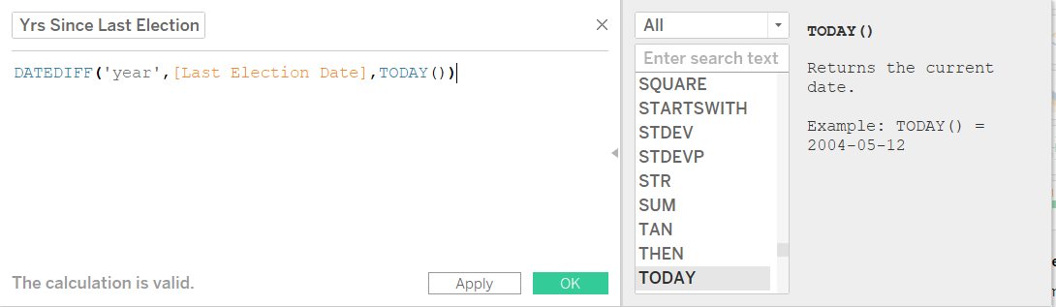

First parameter is number of intervals – that we have defined as ‘year’. We can not use ‘Year’ because Year is another function in Tableau and we can not use reserved keyword in function in Tableau.

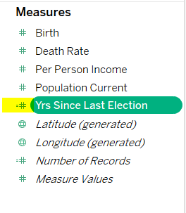

Use the measure in the report:

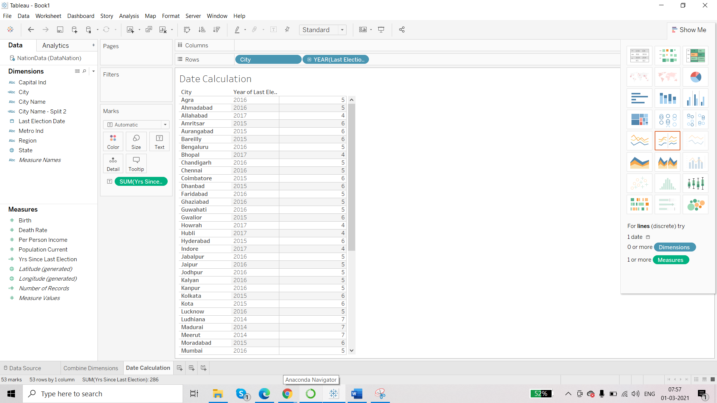

**Logical Calculations**

We can not group measures because they are continuous values. But we can group them using calculated fields.

Scenario- we want to group the ‘Death Rate’ in terms of low, mid high.

* Death rate<10 – low
* Death rate>10- med
* Death rate>15- high

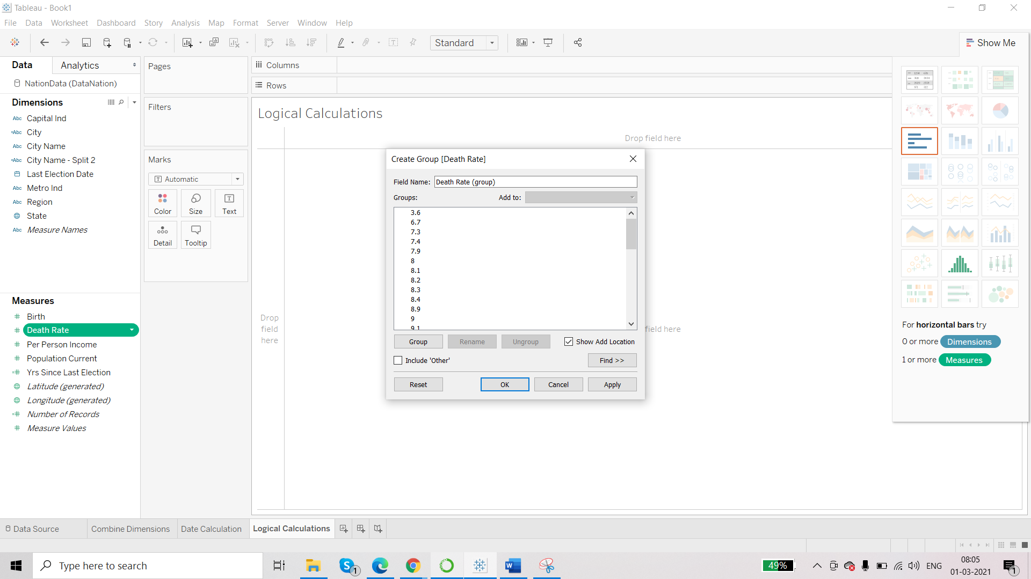

We can not use this ‘Create Group’ option. This is static field and any new data added will not be grouped.

So, we will use calculated field.

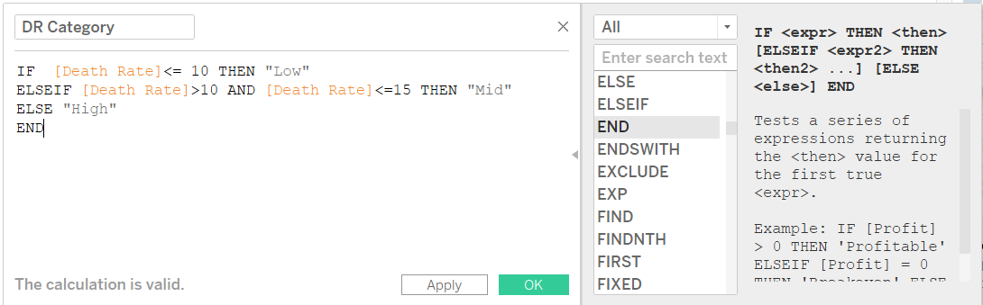

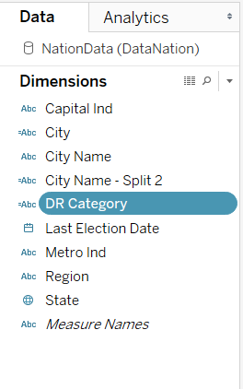

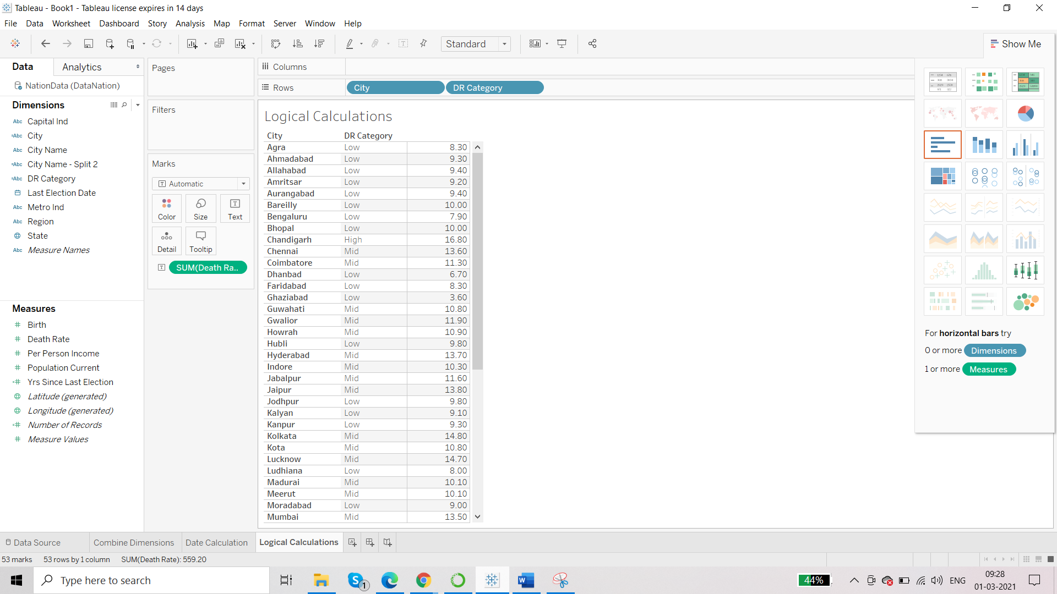

Now we can also see as per the state:

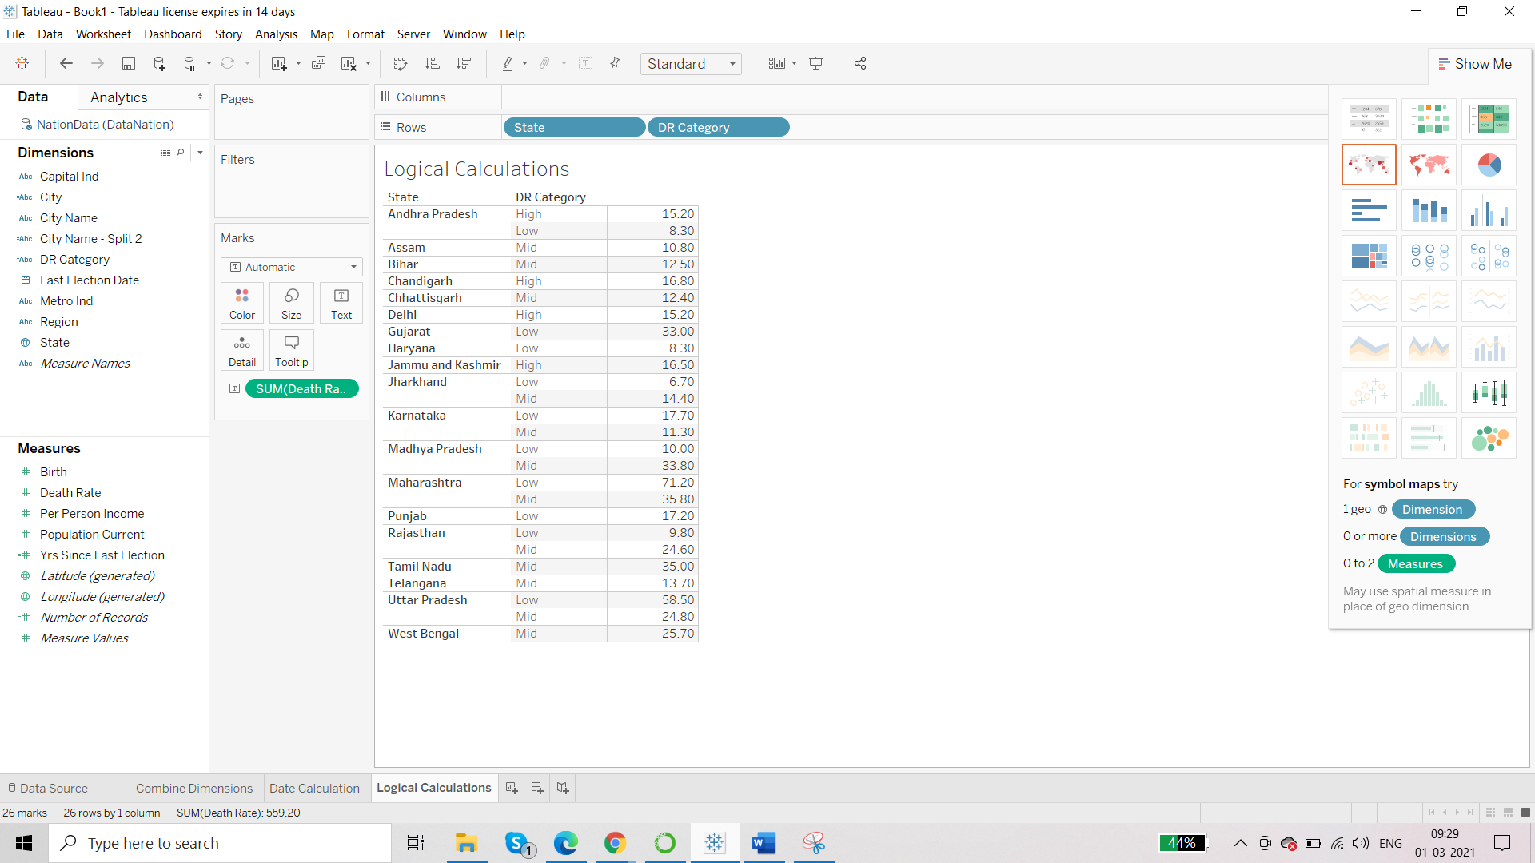

We can see that there are some inaccuracies in the data. For city, each city has 1 value for the category.

But for state we are getting 2 values for death category.

This can be corrected by using Aggregated Calculations.

**Aggregate Calculations**

Scenario 1 --Now, here we have to find average value of death rate for each state and then we will have accurate value for the Death Category

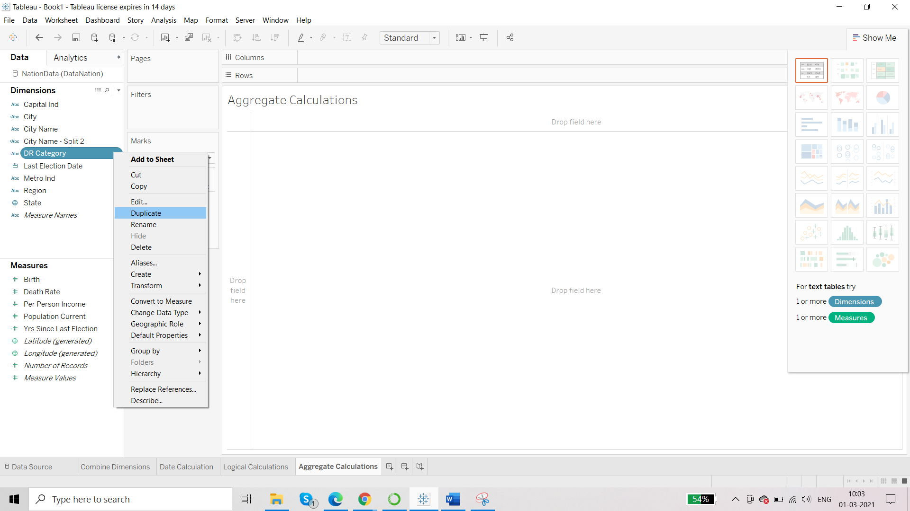

Edit the duplicate one:

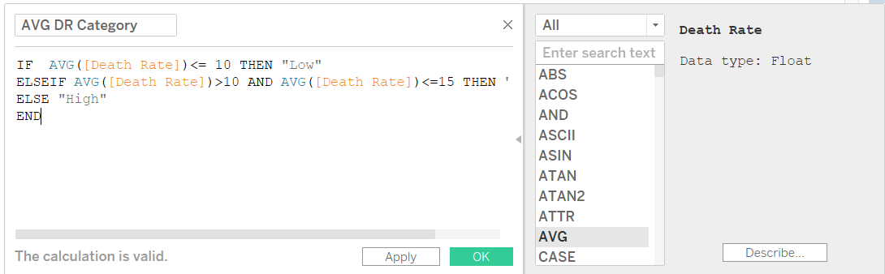

Aggregate calculations will always return you a measure and never a dimension.

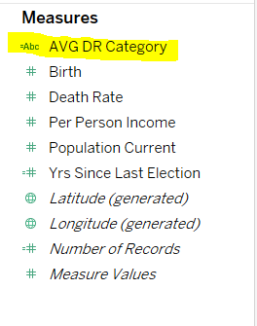

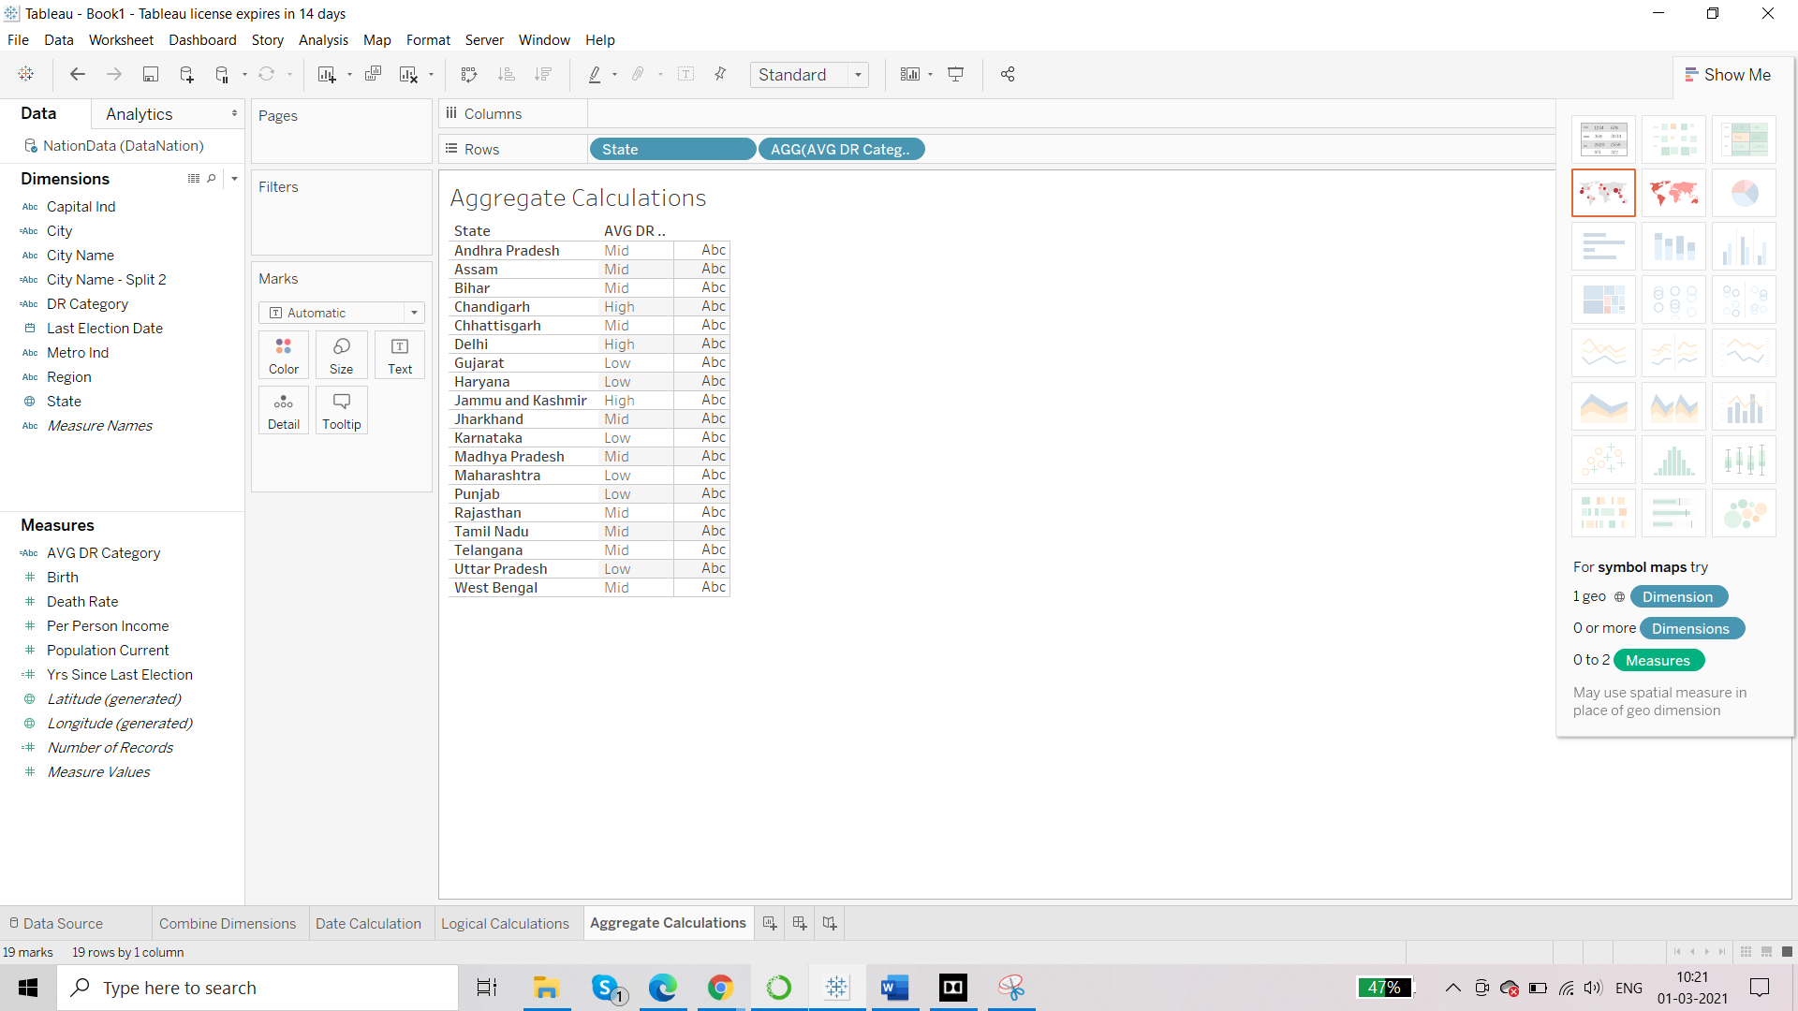

IF [Death Rate]<= 10 THEN "Low"

ELSEIF [Death Rate]>10 AND [Death Rate]<=15 THEN "Mid"

ELSE "High"

END

The above code is same as:

IF [Death Rate]<= 10 THEN "Low"

ELSEIF [Death Rate]<=15 THEN "Mid"

ELSE "High"

END

Scenario 2 – Calculating Birth Rate

Birth Rate = SUM([Birth])/SUM([Population Current])

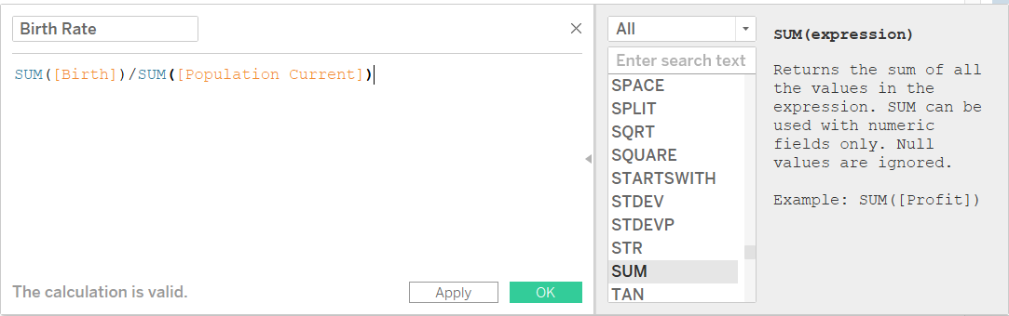

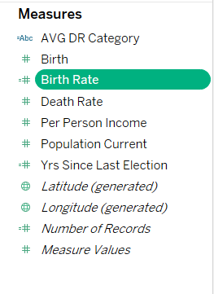

LOD

This also involves calculated fields. LOD means level of details. LOD is a kind of calculation that we perform when use multiple granularity option in a single visualization. LOD is a special calculation or advance level of calculation which is used for a specific business purpose.

We can use LOD for measuring customer loyalty, to find number of orders per customer, to calculate profit per day, to calculate new and existing customers.

There are 3 types of LOD

* + Fixed LOD – returns a measure/dimension
  + Include LOD – returns a measure
  + Exclude LOD – returns a measure

**Fixed LOD**

FIXED level of detail expressions compute a value using the specified dimensions, without reference to the dimensions in the view.

This has a particular format. It is always used with a dimension followed by a measure.

Dataset: Superstore_USA

Fixed LOD

{FIXED [Product Category]:SUM([Sales])}

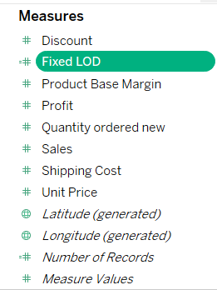

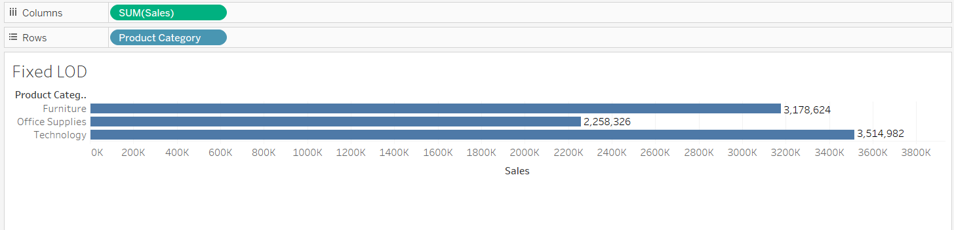

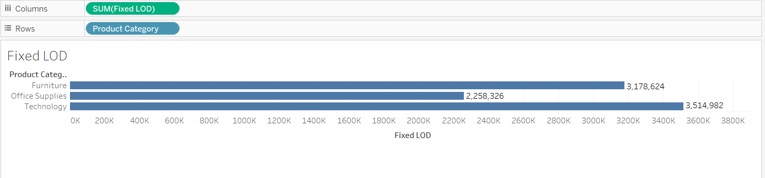

We get the same result with Fixed LOD too.

Add another dimension:

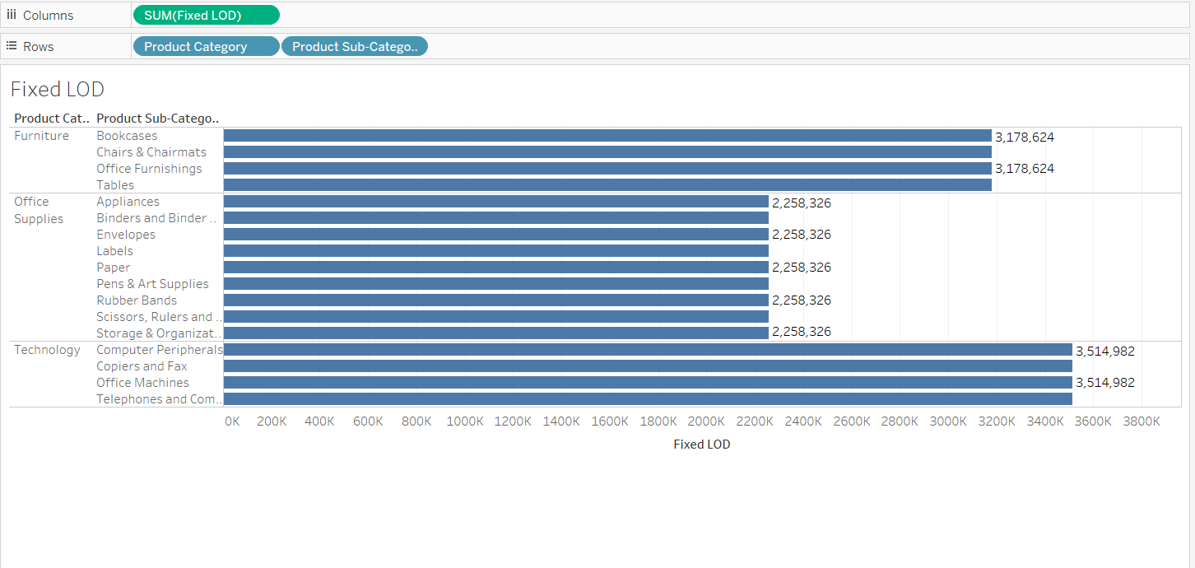

We see that for Product Subcategory also, we have fixed value. This fixed value corresponds to the Product Category. Fixed LOD will not allow other dimensions to show their value.

**Include LOD**

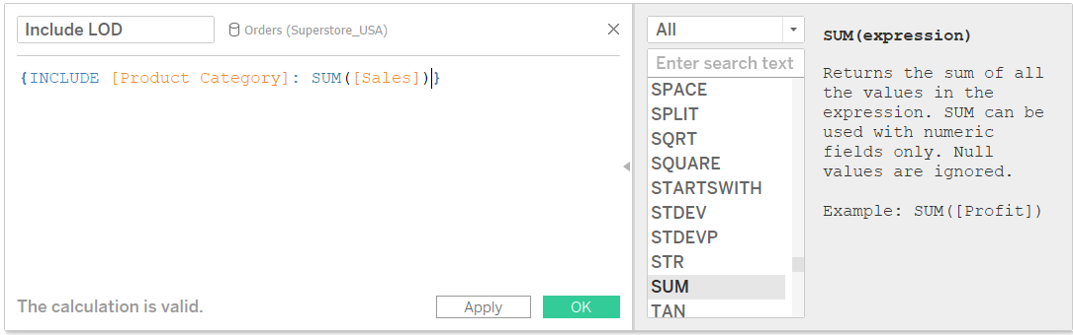

Now:

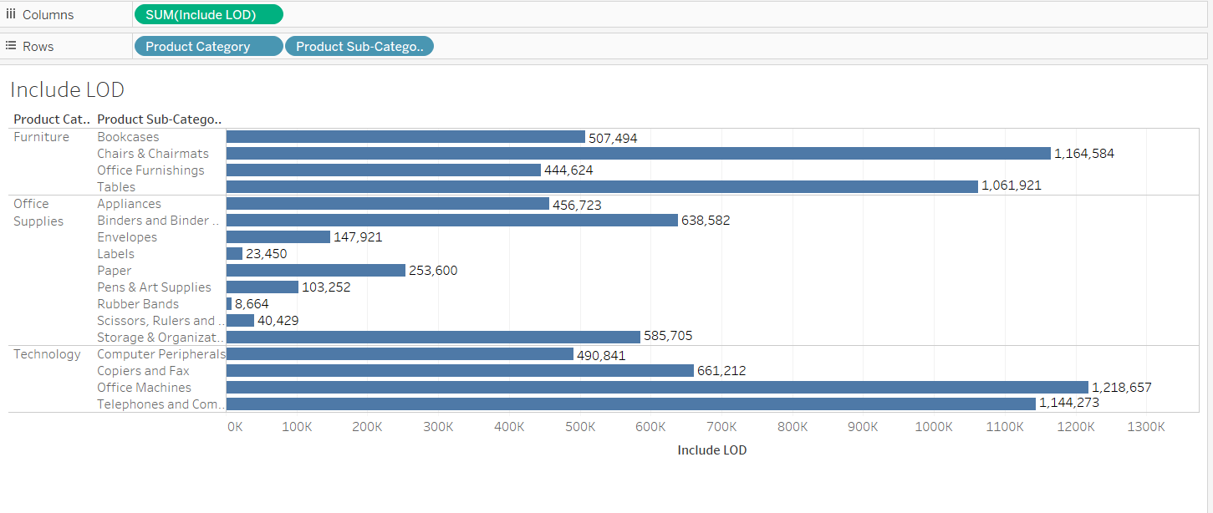

Product category allows Product Sub Category to appear.

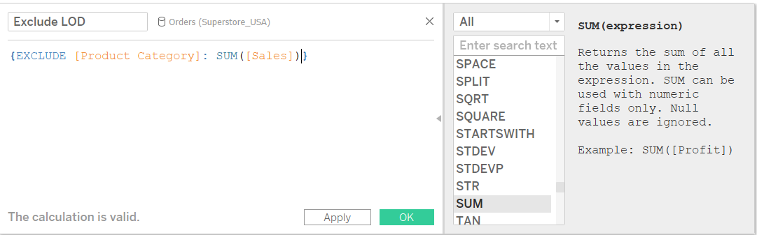

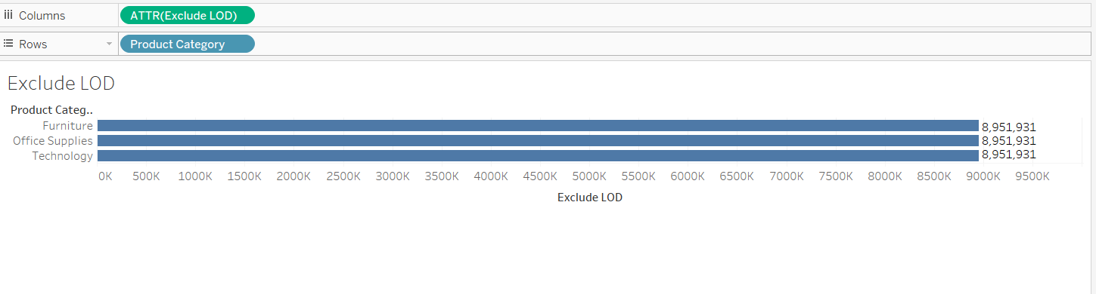

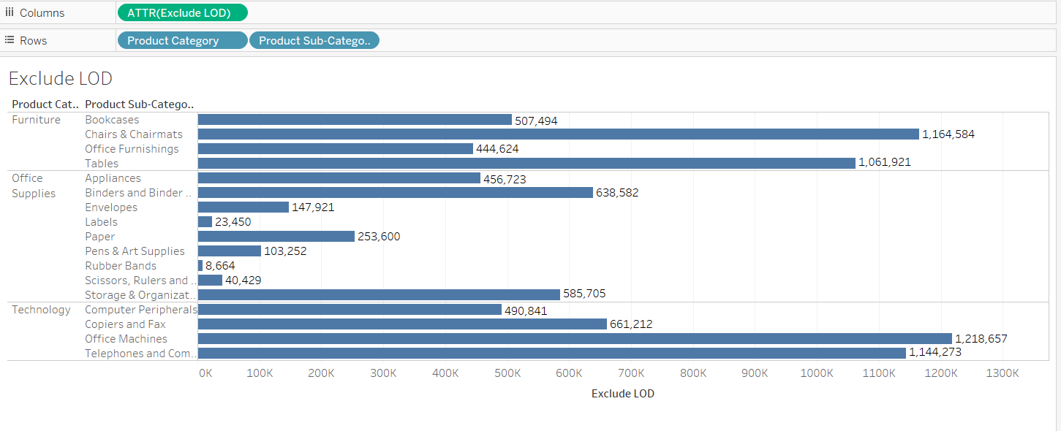

Product Category is excluded.

**Practical Implementation of Fixed LOD: Customer Loyalty**

Loyalty of customers who joined the organization in terms of sales and the percentage of contribution that they have done in terms of their presence in the organisation.

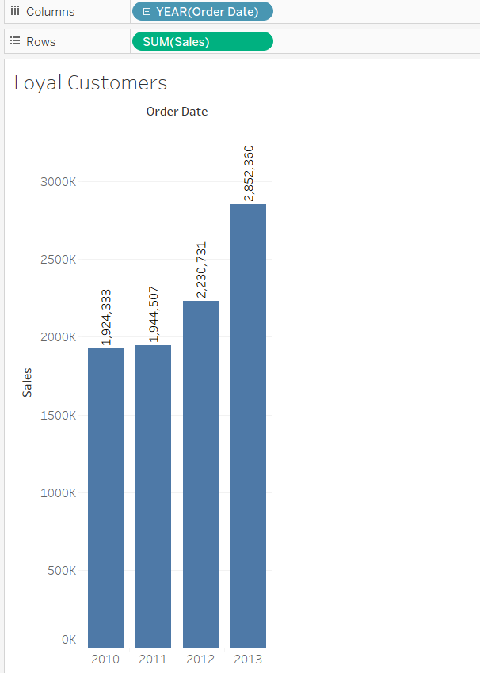

We want to know:

* How many customers were added each year
* How many customers were loyal to the company in terms of sale since the company was started

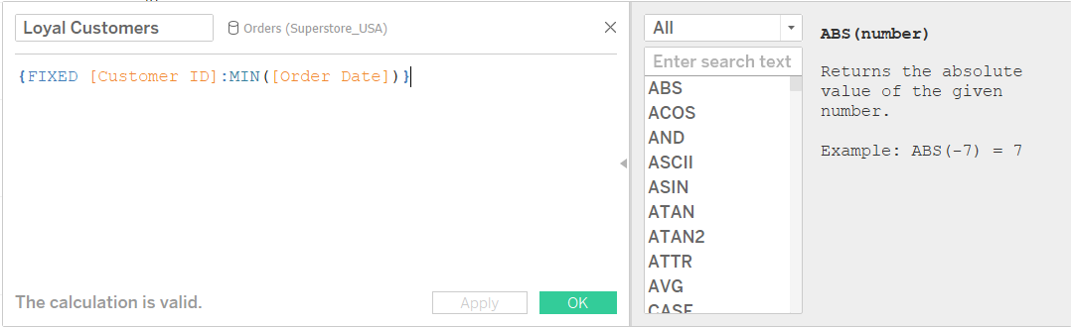

We fix the customer id since it is unique and place this dimension or calculated field over colours.

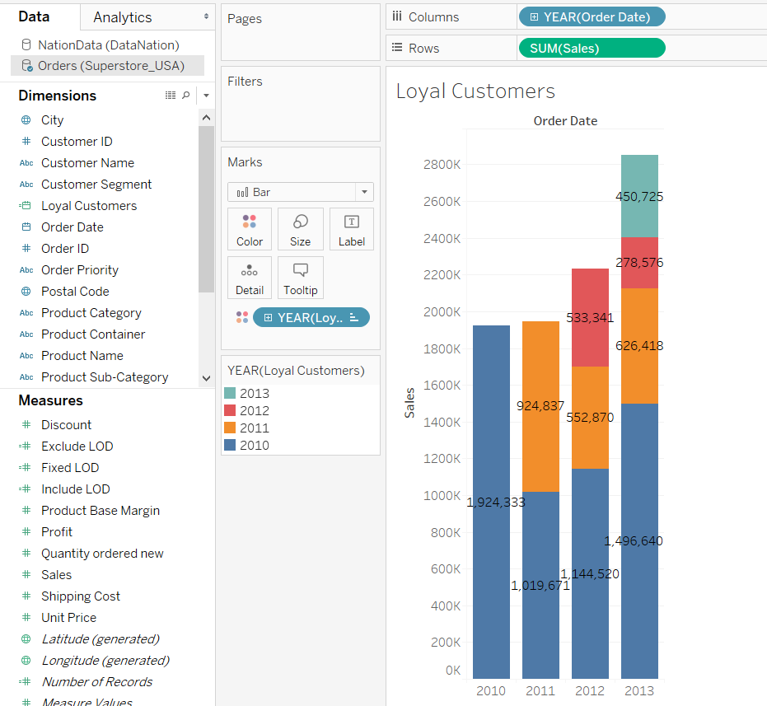

Blue ones are the 2010 customers and in 2010 they contributed to around 19Lakhs.

In 2011 their contribution reduced to 10lakhs but new customers came(orange ones) and contributed arounf 9lakhs.

We can view the same in percentages:

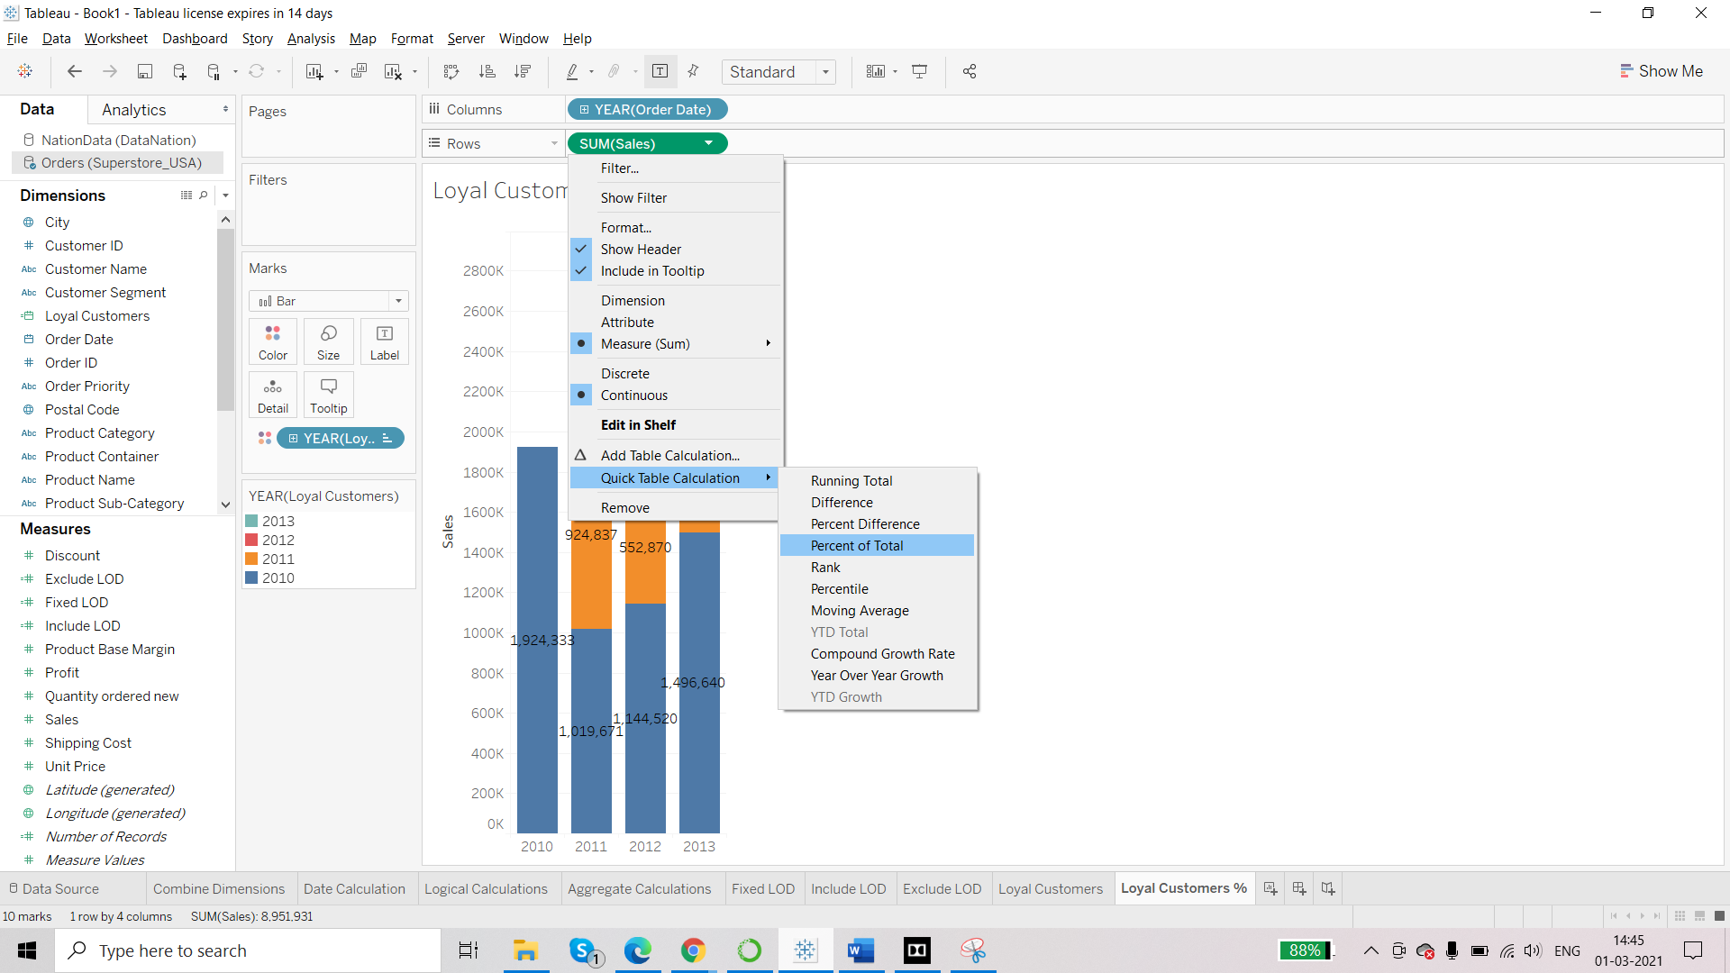

We can view each year as 100% by going to compute using 🡪 loyal customers

**Number of orders per customer**

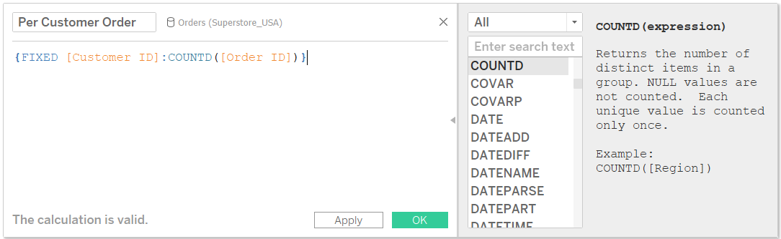

Per customer order – dimension and discrete

Customer id- aggregation – count distinct and continuous

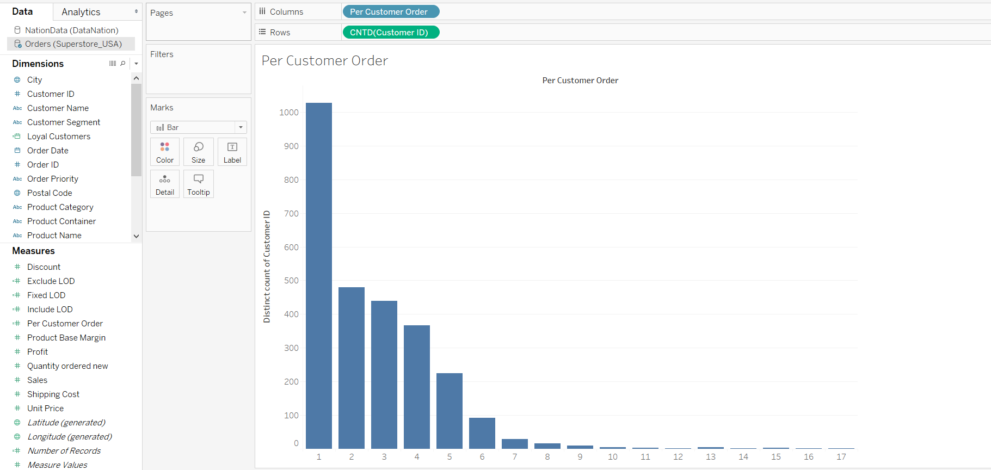

So, there were only 5 customers who have placed 13 orders each so they were more loyal as compared to those who placed 1 order only.

**Profit per day**

Now we will calculate profit that the organization is making per day using Fixed LOD and then we will use if condition to segment it into high, mid or low.

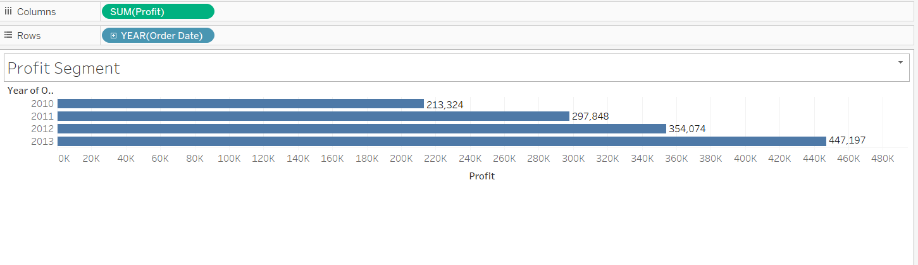

Order date – exact date and discrete

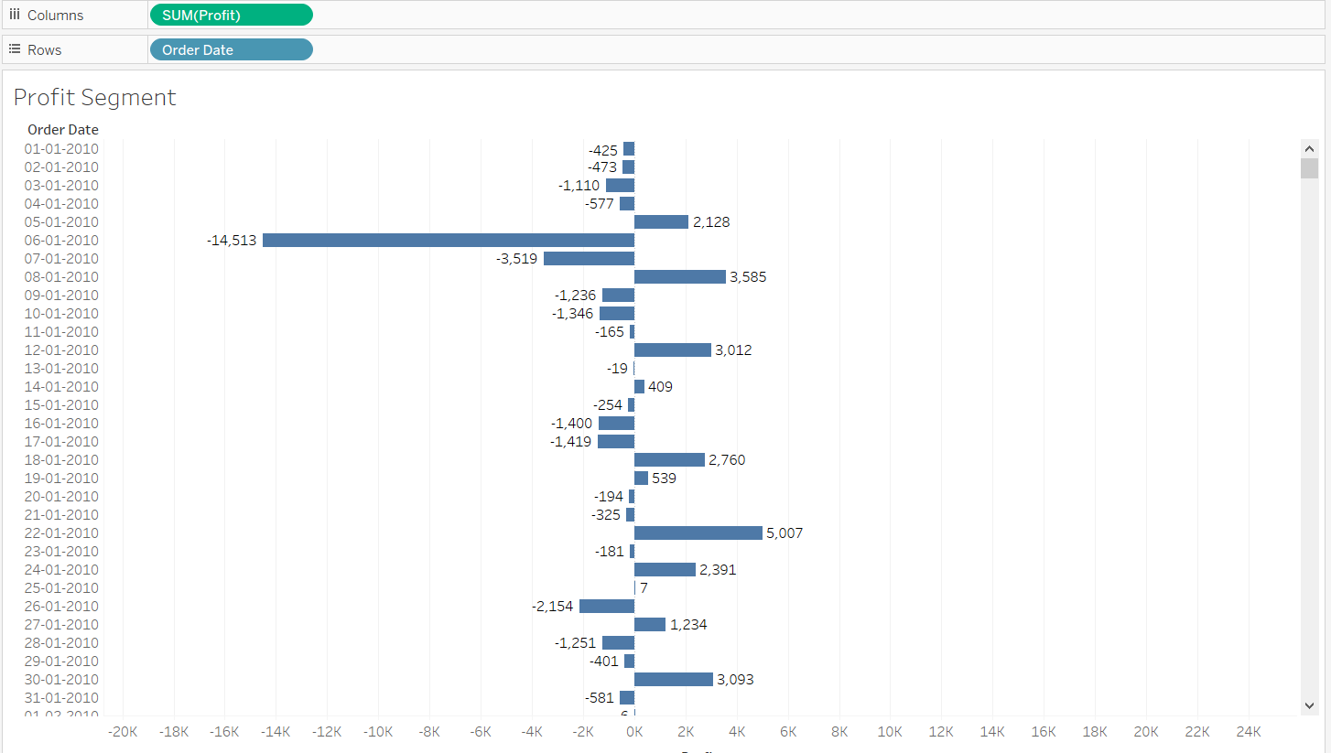

Bring profit over colour mark. We have profit per day and now we will fix this information.

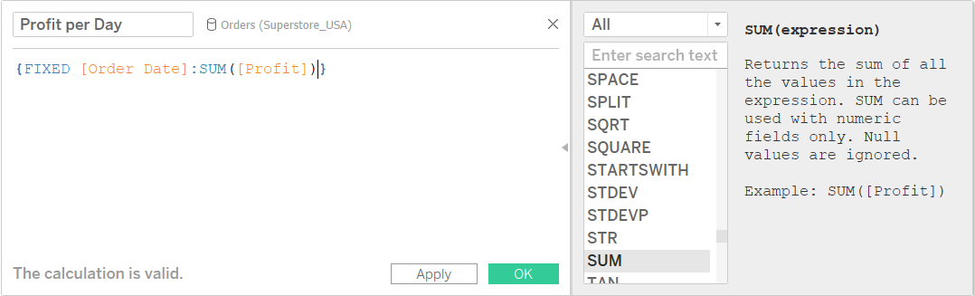

Now we will segment:

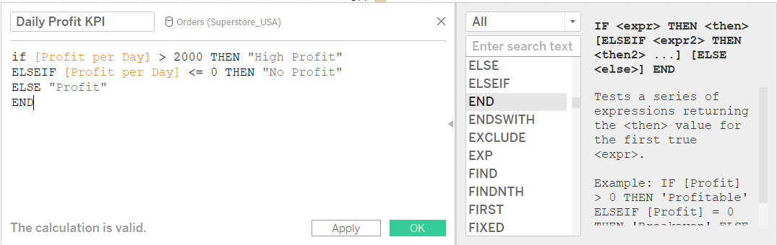

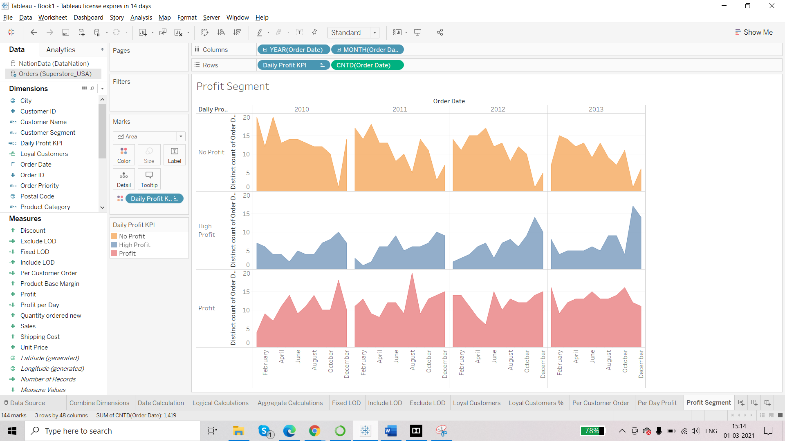

**Finding out new and existing customers**

We will first need to calculate the first order date for each customer

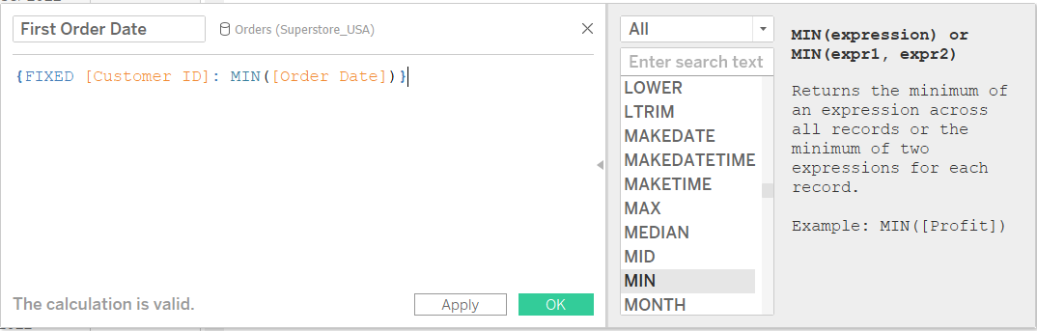

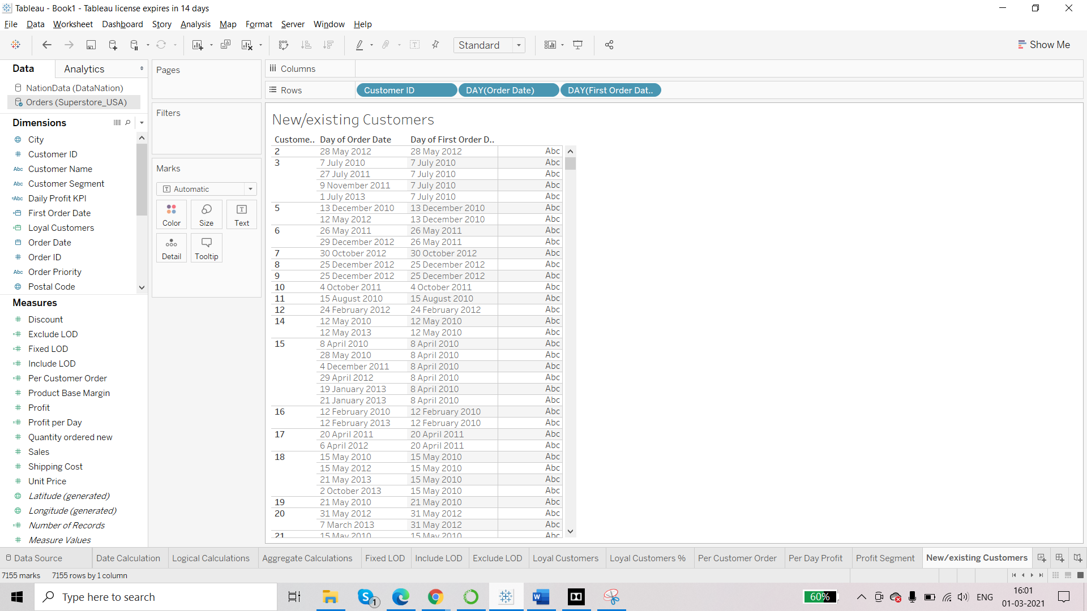

We will now create a segment for new and existing customers by using calculated field

